Multi-Channel Marketing
Utilizing the right platforms to reach the right audience
(aka Cross-Media, Cross-Channel, Omni-Channel)

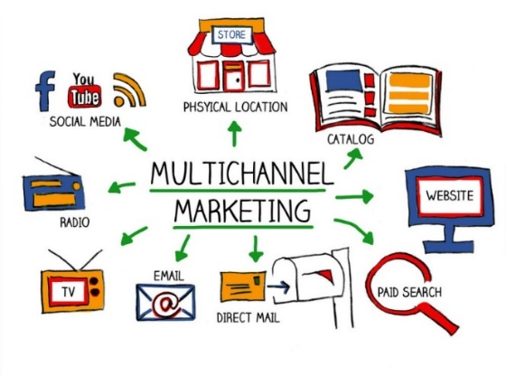
When it comes to prospects and customers all marketing channels, both online &offline, need to be considered.

It Needs to Be:

  - Personal
  - Relevant
  - Engaging
  - Consistent branding and messaging
  - The clients preferred method

Enhancing applications with personalization and cross-media
improves the customer experience and increases ROI.

3 The average number of media types utilized in a campaign
35 Percentage of respondents linking print and digital media
49 Percent of campaigns that have combined print and digital media

(Source: Micro to Mega: Trends in Business Communications, InfoTrends)
Campaign Media Combinations | Response Rates | Conversion Rates
Print only | 6.26% | 7.08%
Print and e-mail | 7.26% | 8.83%
Print and social media | 6.33% | 7.46%
Print and mobile applications | 5.65% | 6.42%
Print, e-mail, social media and mobile applications | 7.49% | 9.21%
N = 443 SMB Firms
Source: Micro to Mega: Trends in Business Communication, InfoTrends 2015
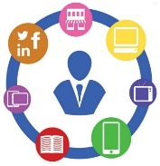
Adding just one additional channel lifted response!!
Utilizing multiple channels reaches a larger audience vie their preferred method
The Best Way to Reach New Prospects
What is the best way for companies that don’t have an existing relationship with you to send you marketing messages?

N = 2,000 Consumer respondents in the U.S. and Canada
Source: Annual State of Marketing Communications: Consumer Survey; Keypoint Intelligence – InfoTrends 2017
A few key stats about multi-channel….

A little bit about us…
We help customers attract, serve and retain clients via the print, mail & digital mediums. For almost 60 years our clients, distributors and re-seller partners throughout North America have trusted us to produce a wide variety of marketing, mail and transactional communications.
Please drop us a line or give us a shout… info@margraphics.com or 800-851-4460

